What is Every Day Counts?

Every Day Counts, or EDC, is a State-based model that identifies and rapidly deploys proven, yet underutilized innovations to shorten the project delivery process, enhance roadway safety, reduce traffic congestion, and integrate automation. Proven innovations promoted through EDC facilitate greater efficiency at the State and local levels, saving time, money and resources that can be used to deliver more projects. The current round of EDC innovations is the sixth such group to be promoted since 2011.

How Does EDC Work?
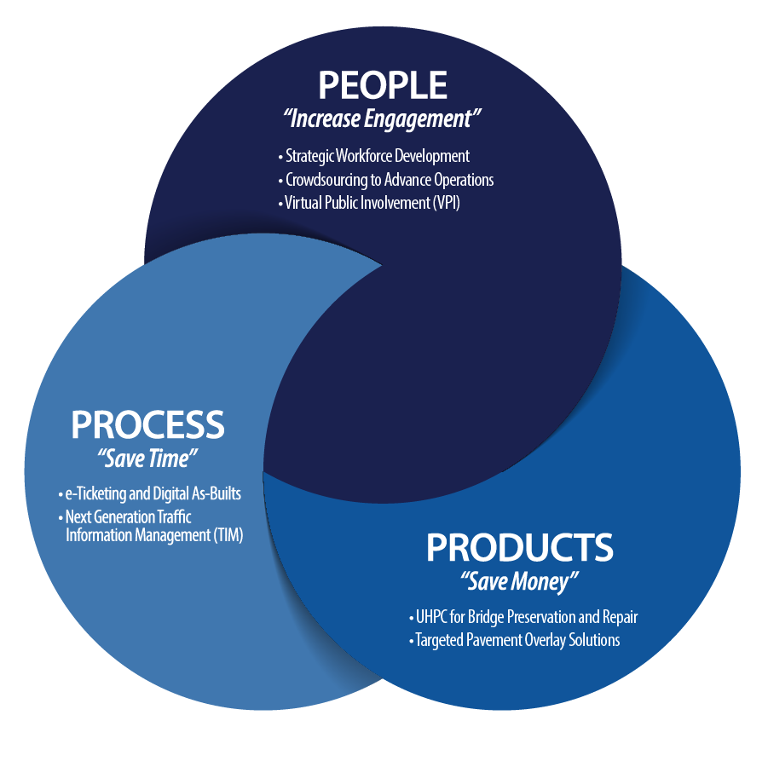
Step 1. Every two years, FHWA works with State transportation departments, local governments, tribes, private industry and other stakeholders to identify a new collection of innovations that merit accelerated deployment.
Step 2. After selecting EDC innovations, transportation leaders gather at regional summits to discuss and identify those innovations that best fit the needs of their respective State transportation program.
Step 3. Following the summits, States finalize their selection of innovations, establishing performance goals for the level of implementation and adoption over the upcoming two-year cycle.
Step 4. States then implement the innovations with the support and assistance of the technical teams established for each innovation.

EDC has made a significant positive impact in accelerating the deployment of innovations and in building a culture of innovation within the transportation community. Since its inception, each state has used 20 or more of the 52 innovations promoted through Every Day Counts, and some states have deployed more than 45. Many of these innovations have become mainstream practices across the country.

The EDC-6 Technologies

Crowdsourcing for Advanced Operations
Crowdsourced data can be obtained whenever and wherever people travel, allowing agencies to capture in real time what happens between sensors in rural regions, along arterials, and beyond jurisdictional boundaries. Agencies at all levels can use crowdsourced data integrated from multiple streams to optimize roadway use for reduced congestion and increased safety and reliability.

E-ticketing
Providing all stakeholders with an electronic means to produce, transmit, and share materials data. enhances safety, streamlines inspections, and improves contract administration processing. This includes the ability to track and verify materials deliveries. Using electronic ticket exchanges enables access via mobile devices and simplifies handling and integration of material data into construction management systems for acceptance, payment, and source documentation.

Digital As-Builts
Using digital data, such as 3D models to build road projects, is becoming an industry standard. Sharing the design model and associated digital project data allows agencies and contractors to streamline project delivery and contract administration, empowering them to collaborate on challenges "virtually" before they get to the field. Digital information is further leveraged when the model is updated, and other data incorporated, to reflect the as-built condition for future maintenance, asset management, and rehabilitation activities.

Next-Gen TIM (Traffic Incident Management)
Traffic Incident Management (TIM) programs aim to shorten the duration and impact of roadway incidents and improve the safety of motorists, crash victims, and responders. New tools, data, and training mechanisms are available that can benefit both new and existing TIM programs, including local agency and off-interstate applications.

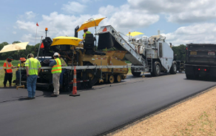
Strategic Workforce Development
The demand for highway construction, maintenance, and operations workers is growing, while emerging technologies require these workers to have new skills. The Highway Construction Workforce Partnership has developed new resources and innovative strategies for identifying, training, and placing individuals into the contractor workforce, filling the construction jobs that support the highway system.

Targeted Overlay Pavement Solutions (TOPS)
Pavement overlays represent a significant portion of highway infrastructure dollars. State and local highway agencies can maximize this investment and help ensure safer, longer-lasting roadways by employing innovative overlay procedures that will improve pavement performance, lessen traffic impacts, and reduce the cost of pavement ownership.

UHPC for Bridge Preservation and Repair
Ultra-high performance concrete (UHPC) is a new material for field-cast connections between prefabricated bridge elements. Bridge preservation and repair is an emerging and promising application for UHPC. UHPC-based solutions are robust, offering superior strength, durability, and improved life-cycle cost over traditional methods. State and local agencies can deploy UHPC for bridge preservation/repair to maintain or improve bridge conditions.

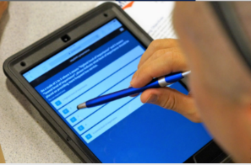
Virtual Public Involvement (VPI)
Public engagement during transportation project planning and development helps agencies identify issues and concerns early in the process, ultimately accelerating delivery. These strategies supplement traditional face-to-face information sharing with technology platforms that increase the number and variety of methods agencies use to inform the public, receive feedback, and collect/consider comments.

Benefits for New Jersey

- Accelerated Project Delivery
- Improved Operations
- Increased Safety and Reliability
- Cost Savings
- Time Savings
- Improved Project Quality
- Improved Travel Times
- Increased Efficiency
- Proven Training
- Increased Flexibility
- Increased Performance
- Versatility
- Durability
- Improved Communication
- Increased Collaboration
- Expanded Engagement

Looking for More Information?

FHWA EDC website:
https://www.fhwa.dot.gov/innovation/everydaycounts

FHWA Center for Accelerating Innovation resources:
https://www.fhwa.dot.gov/innovation/resources

New Jersey State Transportation Innovation Council (STIC):
https://www.njdottechtransfer.net/nj-stic

