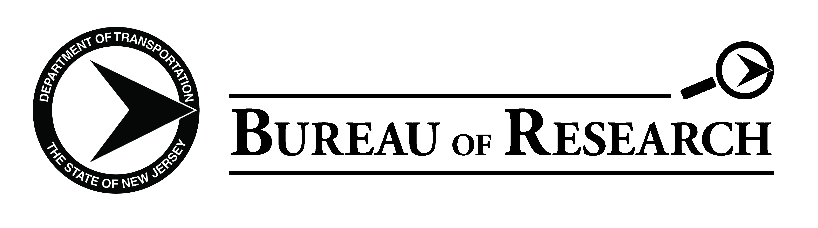
New Jersey Department of Transportation

24th ANNUAL RESEARCH SHOWCASE CALL FOR POSTERS

The New Jersey Department of Transportation (NJDOT) Bureau of Research invites you to display posters on research related to transportation at the 24th Annual Research Showcase (scheduled for October 26, 2022 at The Conference Center at Mercer County Community College in West Windsor, NJ).

We welcome you to display any transportation related projects that are completed or substantially completed research studies. These do not have to be projects funded by the NJDOT. The poster displays must be on site and set up between 8:00 am and 8:30 am on the morning of the event. Posters will be on display all day. We will also require a PDF of your poster by October 16, 2022.

Please submit your poster session topics to Ryan Stiesi (rps118@soe.rutgers.edu) of Rutgers CAIT no later than September 22, 2022 with the following information:

- Poster Title
- Our theme this year is “Advancing Equity in Transportation”; please specify which topical area your poster best aligns: Infrastructure, Safety, or Equity/Mobility.
- Name and Email for the person who will be accompanying the poster and responsible for set up
- Affiliated academic institution (i.e. NJIT, Rowan, Rutgers, etc.)
- Whether you need an easel provided- YES or NO

Posters should arrive ready for display. Poster board will NOT be provided at the event.

Thank you for your interest and participation in the NJDOT Research Program.

