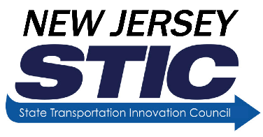
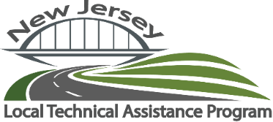
NJ Build a Better Mousetrap Entry Form

People involved in the transportation industry often find better ways to do their jobs. Whether it’s a new gadget that improves the quality and safety of a project, or an innovative process that reduces costs and improves efficiency, it is typically the people on the front lines who discover the latest and best practices.
We are looking for submissions from employees of local or state public agencies (municipalities, counties, parks commissions, NJ Department of Transportation, NJ Transit) that have created different solutions to problems or found better ways of doing things. Submissions must reflect implemented products, procedures, or processes. We will gather the best entries from around the state and judge them using a 5-point rating system (cost, benefits to the community, ingenuity, ease of transferability, and effectiveness.)
Think you’ve built a better mousetrap? Fill out the entry form below to submit your innovation! We look forward to receiving your entries and best of luck to everyone!

Organization: __________________________________Contact Person: ______________________________________

Phone Number: ________________________________ Email: ______________________________________________

Address: __________________________________________________________________________________________

City: _________________________________ State: ___________________ Zip Code: _____________________

Entry Title: ________________________________________________________________________________________

Please check the category that this entry is being nominated for:
- ____Innovative Project– Any solution that addresses any or all phase(s) of the ‘project’ life cycle – Planning, Design/Engineering, Construction, Operations and Maintenance. This project shall introduce new ideas, is locally relevant, original, and creative in thinking.
- ____Bold Steps– Any locally relevant high-risk project or process showing a break-through solution with demonstrated high-reward.
- ____Smart Transformation– A locally relevant significant change in any transportation activity or process that is SMART “Specific, Measurable, Achievable, Realistic and Time-bound” in nature that results in improved efficiencies.
- _____Pioneer– A locally relevant product/tool that is among the first to solve a maintenance problem with a home-grown solution.

Problem Statement:

Discussion of Solution:

Labor, Equipment, Materials used:

Savings/Benefits to the Community:

Cost:

Please include a photo of your project with submission. Please add additional pages if needed.

Entries will be accepted on a continual basis, but each cycle will have a deadline of May 1 of each calendar year to be considered for that year’s awards. Please submit all entries by email to:
New Jersey Local Technical Assistance Program: jleli@soe.rutgers.edu
https://cait.rutgers.edu/mousetrap

